# Requirements

Java Runtime Version 6.

For OS X this is installed on version 10.6 and above.

Windows

If you dont have Java installed please install it from <http://java.com>

# Installation

**Windows**

Unzip SampleMapBuilder.zip

Run SampleMapBuilder.exe

**OSX**

Unzip SampleMapBuilder.zip

Run ‘Sample Map Builder’ application

# Getting Started

For a quick start :

1. press the ‘Browse’ button on the toolbar. BrowseButton.png
2. Select a folder with samples in and click OK.

As soon as OK is clicked the selected folder and all subfolders will be scanned for sample files (currently wav and aiff).

Once scanning is complete a flat list of scanned folders will appear in the left panel showing the name of the folder (actually the name of the output map but we’ll get to that later) and how many sample files were found within that folder.

1. Open the configuration window. Settings-Button.png
2. Make sure the Layout is set to ‘Individual’
3. Activate an output format, e.g. SFZ :
4. Click the Folder button to select the output location
5. Click OK
6. Click the ‘Export’ button. Export-Button.png

Now if you browse to the chosen output folder using Explorer / Finder you should see the created .sfz files (or whichever format you chose)

Try opening a map in your sampler to check it all works :)

If you are only interested in using one format and creating maps for personal use, this may be all you need to do. If you are interested in using other formats and output layout options then please read on.

# The Interface

Main Window

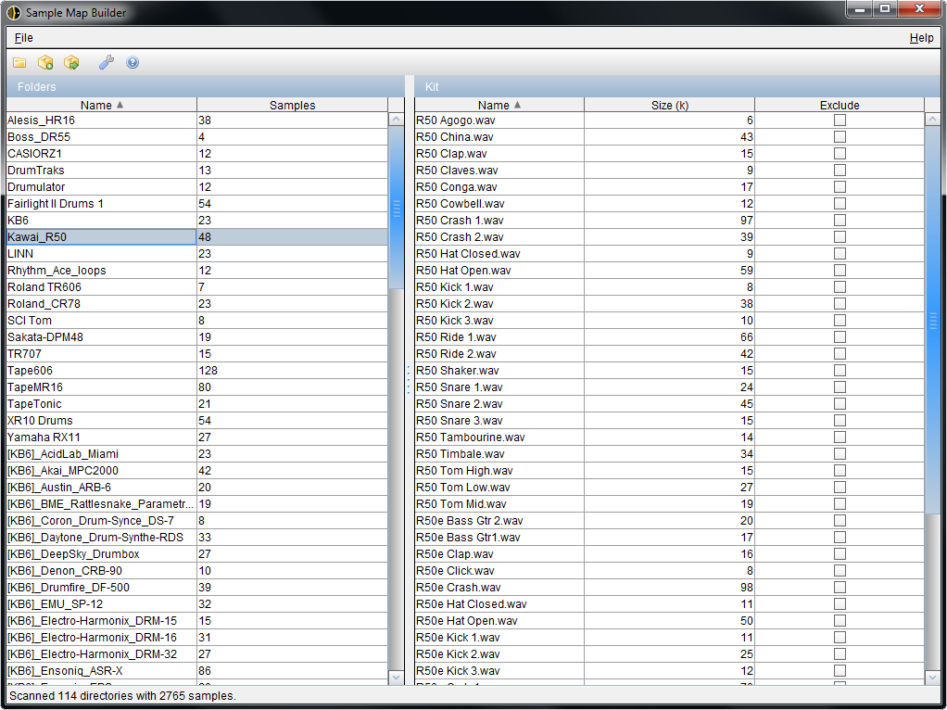

The main Sample Map Builder window is divided into 2 sections. The list on the left shows the scanned folders which will be used to generate sample maps and the list on the right shows the samples within the selected folder.

Selecting an entry on the right will play the sample through the default audio device. You can navigate the list using the cursor keys and use SPACE to toggle the **exclude** setting.

Sorting and Ordering Samples

The samples within a map can be sorted by clicking the table headers or by dragging and dropping samples into the place you want.

Once selected, either through the table sort or by drag and drop, the map will remember its own sample order. This allows you to customise the midi key mapping for every folder.

Each map will be exported using the order you have chosen.

The Toolbar

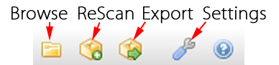

Browse : Choose the base directory for scanning. The directory will be scanned as soon as it is selected.

ReScan : If you have changed the contents of the directory since the initial scan, this will perform the scan again to pick up any changes

Export : Write the sample maps to disk

Settings : Configure output layout and format settings.

Settings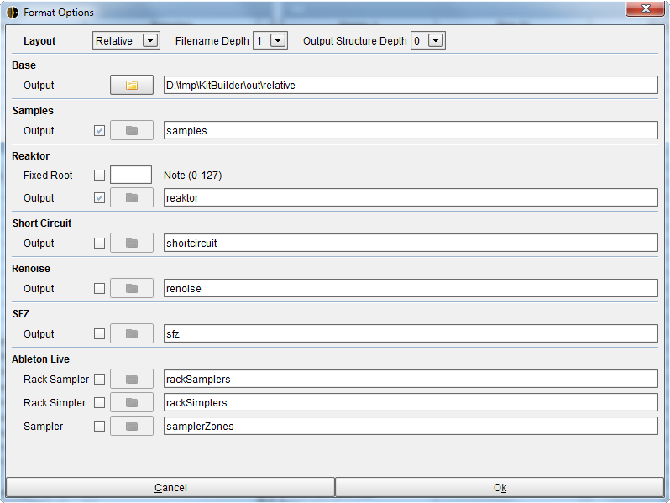

The settings window allows you to configure the output structure, naming and which formats are exported.

Configuring Output

There are 3 different layout options : Individual, Relative and Source

Individual

This layout allows you to specify a different output directory for each format.

Relative

Relative output uses the **Base** setting to determine where all formats will be exported.

For each format you can specify a directory below the Base directory for writing the sample maps. Multiple directories can be specified by using / as a separator, e.g. sfz/acoustic.

Source

Selecting Source output will write the sample maps into the same directory as the samples. In this mode the Sample Output option is unavailable.

**Output Examples**

Individual Layout

Each output folder can be set anywhere on any disk :

SFZ : C:/SampleMaps/SFZ

Sampler Zones : C:/AbletonUserLibrary/Presets/Sampler/

Both the filename depth and output structure depth settings are used to determine the final output location and filename

Relative Layout

This layout uses the ‘base path’ setting to determine to root of the output folder structure.

Each output format folder is specified relative to this base folder, e.g.

Base Folder : C:/Output/

SFZ Relative Path : sfz

Output File : C:/Output/sfz/Kicks.sfz

Source Layout

All generated map files will be placed into the same folder as the source samples :

If the source samples are :

C:/Samples/Drums/Acoustic/Kicks/Kick1.wav

C:/Samples/Drums/Acoustic/Kicks/Kick2.wav

Etc..

For a filename depth of 1 the SFZ output will be

C:/Samples/Drums/Acoustic/Kicks/Kicks.sfz

When using the ‘Source Layout’ the output folder depth control does not apply but the filename depth control is used.

Filename Depth

This controls how many levels of folders are used to create the map filename. Folder names are separated by an underscore

1 is the minimum, e.g.

Kicks.sfz

Snares.sfz

2 :

Acoustic_Kicks.sfz

Electronic_Snares.sfz

3 :

Drums_Acoustic_Kicks.sfz

Drums_Electronic_Snares.sfz

All : This will use all folder names from the folder with samples in, up to the source root.

Audio_Samples_Drums_Acoustic_Kicks.sfz

Output Structure Depth

This controls how many levels of source folder structure will be re-created in the output folder.

Note all examples here are with a filename depth of 1.

0 : C:/Output/Kicks.sfz (No subfolders in output)

1 : C:/Output/Acoustic/Kicks.sfz

2 : C:/Output/Drums/Acoustic/Kicks.sfz

All : This setting will match the source folder structure in each output location.

Sample Files Output

If the option to copy ‘Samples’ to output is active, the source folder structure will be replicated regardless of the ‘Output Structure Depth’ setting. This is to prevent sample files with the same name from overwriting each other.

e.g.

Source Files :

C:/Samples/Drums/Kicks/Kick.wav

C:/Samples/Drums/Snares/Snare.wav

C:/Samples/Drums/Kicks/Layers/ClickKick.wav

With the following configuration :

1. C:/Samples/Drums folder is chosen as the source root
2. Sample output directory is set to C:/Output
3. Layout is Individual folders :

The output will be :

C:/Output/Drums/Kicks/Kick.wav

C:/Output/Drums/Snares/Snare.wav

C:/Output/Drums/Kicks/Layers/ClickKick.wav

NOTE : When this option is active any output map will reference the copied samples, not the source files.

This means that output with formats which support relative sample references (SFZ, Ableton Live) can be easily packaged and distributed to other users.

See the ‘Creating and Distributing Sample Maps’ section for details and examples.

# Supported Formats

SFZ

This is a widely supported text-based format and has been tested on **Battery**, **Kontakt**, **DirectWave**, **Aria Player** and **Alchemy**.

SFZ format only supports relative paths, so if you use either Individual or Source output layouts then moving either the samples or the .sfz files will result in the samples not being found.

**Camel Audio Alchemy**

After loading the SFZ into Alchemy you will need to change the loop mode from

‘Continuous’ to ‘None’ as currently Alchemy interprets the ‘one_shot’ setting as looping.

**Battery**

When Battery 4 loads an SFZ it places all of the zones into one Pad as ‘layers’.

Reaktor

Reaktor supports 2 types of .map file, one with the samples embedded and one without sample data. Currently Sample Map Builder only creates the 2nd type without the sample data within the file.

References to samples within the map file are stored as absolute paths, so the .map file itself is freely movable on the filesystem but the samples have to stay where they are.

This also means that it is difficult to distribute sample maps as it is unlikely that other people will keep their samples in the same places you do.

Support for the embedded format is under consideration.

Ableton Live

There are 3 different ‘targets’ available for Ableton Live : Drum Rack : Simplers, Drum Rack : Samplers and Sampler with Zones.

The 2 Drum Rack targets each place a single Simpler / Sampler on each cell for every sample. Currently there are no macro mappings configured for this output.

The Sampler Zones output maps each sample to one zone in a single Sampler device.

Like the sfz format, all sample references in the ableton map files are relative.

Renoise

The Renoise format is ‘self-contained’ in that an instrument also includes all of the samples in .flac format. This means any renoise instrument file is freely relocatable and easily distributed.

ShortCircuit

ShortCircuit is a Windows only VST which is now discontinued but its still one of the best sample playback VSTs around.

You can download it for free from <http://www.vemberaudio.se/shortcircuit.php>